Welcome!
Date
Name
Spouse
Address
City
State Zip _________
Email

Please Contact By
❑ Card  Phone  Visit

Telephone Best Time to Call
Home ______________
Work ______________

Guest: First Time Second Time
Are you a church member: yes no
Church
City, State

Circle Appropriate Age/Grade Group(s)
Preschool: Ages: B-1 2-3 4-5
Children: Grades: K 1 2 3 4 5 6
Youth: Grades: 7 8 9 10 11 12
Adults: Ages:18-29 30s 40s 50s 60s+

How did you learn about our church?
Newspaper Friend Yellow Pages Mail
Other

I am a guest of:

New in the Community? Yes No
Names & ages of children at home

Weekly Service & Activity Schedule
January 12th, 2014
9:45 a.m. Sunday School
11 a.m. Morning Worship
Covered Dish Dinner

6 p.m. Evening Services
Business Meeting

Week of January 13 - 18

Tuesday, 2:30 p.m. Elgin Nursing Home Birthday Party
Wednesday, 6:30 p.m. Youth Activities
Wednesday, 6:45 p.m. Adult Prayer & Bible Study
Wednesday, 7:30 p.m. Praise Team Rehearsal
Thursday Association Fish Fry - Somerville
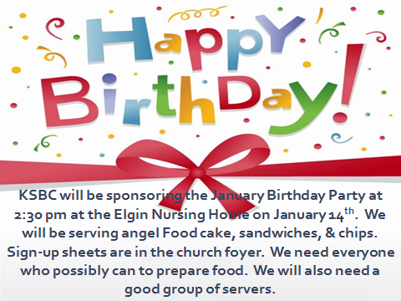

Upcoming Events

January
23 Adult Fellowship
25 My Hope America (Deacons)
26 Baptist Men’s Day (Men’s Service)

Note: Beginning this month Birthday & Anniversary Recognitions will occur on the final Sunday Morning of each month.
Knobbs Springs Baptist Church

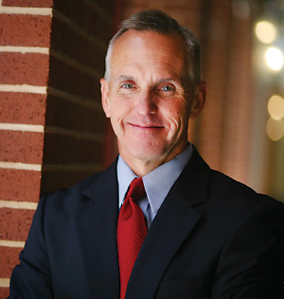

A Very Special Welcome to
Dr David Hardage, Executive Direct for Texas Baptists
And his wife, Mrs. Kathleen Hardage.

Welcome to Knobbs Springs Baptist Church!!!

January 12, 2014

Church Information:
KnobbsSpringsBC.com KnobbsSpringsBaptist@gmail.com
1662 CR 305, McDade, Texas 78650 512-273-2743
Brother Dwight Reagan 512-247-6448
Kimberly Tabor, Office Manager 512-698-2804

